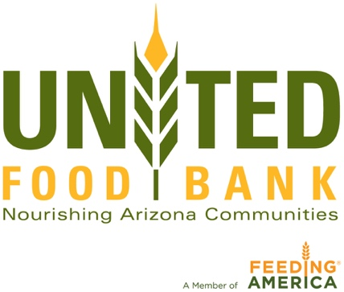

For more information, contact:
Barb Harris
teamworks@teamworkspr.com
480-296-5573

United Food Bank Cooler Expansion Ribbon Cutting
and News Conference

WHAT
United Food Bank celebrates a 2500 sq. ft. expansion with a Ribbon Cutting/News Conference. Governor Doug Ducey to be in attendance and speak.

WHEN
Wednesday, Aug. 15 at 11:30 a.m.

WHERE
United Food Bank, 245 S. Nina Dr., Mesa, AZ 85210 in warehouse.

DETAILS
To celebrate an upgraded cooler expansion that will increase the quantity and nutritional food capacity that we offer to more 200 partner agencies throughout the East Valley and eastern Arizona.

Thunderbirds Charities awarded United Food Bank a $60,000 grant and a matching grant from the Diane & Bruce Halle Foundation for the cooler expansion.

Under Gov. Doug Ducey’s budget released Jan. 12, 2018, food banks would get $1 million to buy equipment to transport and store more “farm fresh” food that requires refrigeration. United Food Bank will receive a sum of that million dollars for the refrigeration upgrade.

PHOTO OPPS
UFB Staff will be available for questions after the ribbon cutting.

There will be a video and photo opportunity will begin at approximately 11:30 a.m. in the warehouse in front of the entrance to the new cooler.

