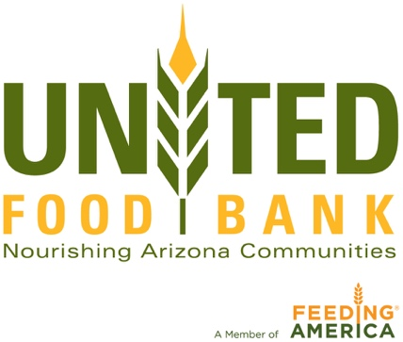

For more information, contact:
Barb Harris
teamworks@teamworkspr.com 480-296-5573

United Food Bank/National Association of Letter Carriers Food Drive
Saturday, May 12

What: Area-Wide Food Drive
The annual National Association of Letter Carriers “Stamp Out Hunger” Food Drive is an essential opportunity for area food banks to stock their shelves for the coming summer months when need typically increases and donations tend to decrease.

You can capture the spirit of community generosity as food donations by area residents are accumulated.

United Food Bank (UFB) works with 222 community partners to serve more than 228,000 Arizonans in need living in the East Valley and eastern Arizona and is a member of the Feeding America network.

When: Saturday, May 12
Residents place non-perishable food donations by their mailboxes by 8 a.m. for their local carrier to pick up. These donations will begin arriving at area post offices by 12 noon.

Where: Downtown Mesa Post Office
135 N. Center Street, Mesa

Video

Opps: Interview with Dave Richins, CEO of United Food Bank
Letter Carriers delivering food to Post Office
Volunteers sorting food and packing it to go to United Food Bank

MEDIA NOTE: DAY OF: To arrange for a spokesperson for on-site interviews, please contact Tyson Nansel by calling or texting 602-818-1763‬.

